AI-Augmented Backend Development Project :

TITLE : AI – FAQ ASSISTANT

Project Description

In a Single Paragraph
AI – FAQ ASSISTANT is an AI-Augmented backend Web Application developed using the (MongoDB, Express.js,Node.js) integrated with Artificial Intelligence capabilities such as Large Language Models (LLMs), Semantic Search, Vector Search, and Intelligent Recommendations. The system enables users to interact with data through natural language, receive AI-generated insights, perform semantic searches, upload and analyze documents, and automate decision-making processes. By combining traditional backend development with modern AI technologies, the platform delivers an intelligent, scalable, and user-friendly experience that improves productivity, accessibility, and operational efficiency.

Scenario
Write the Scenario section by describing the real-world problem or situation that your application is designed to solve.
Explain the scenario in 2–3 paragraphs and cover the following points:
Identify the Problem
Explain a real-world problem faced by users or organizations in the selected domain. Mention the limitations of traditional systems or manual processes.
- Explain the Need for AI
Describe why traditional approaches are not sufficient and how Artificial Intelligence can improve the existing process.
- Describe the Proposed Solution
Explain how your < Project Name > addresses the identified problem using AI capabilities such as:
  - AI Chatbot
  - Content Generation
  - Question Answering
  - Semantic Search
  - Vector Search
  - Intelligent Recommendations
  - Document Analysis
  - AI-powered Insights
Structure :
- Problem:
Customers often have difficulty finding quick and accurate answers to frequently asked questions. They may need to search through websites, documents, or contact customer support repeatedly, which takes time and increases the workload of support staff. Common questions about products, services, procedures, and policies may also receive delayed or inconsistent responses.

- AI Solution:
The AI FAQ Assistant uses Artificial Intelligence to understand users’ questions and provide relevant answers instantly. It can use Natural Language Processing (NLP) to understand different ways of asking the same question and retrieve suitable answers from a predefined FAQ knowledge base. Features can include 24/7 chatbot support, intent detection, keyword matching, context-based responses, and fallback responses when an answer is unavailable.

- Impact:
The application benefits customers, students, employees, organizations, and support teams by providing fast and accessible information. It reduces repetitive queries handled by support staff, improves response time, provides consistent information, and makes the overall support process more efficient.

System Requirements :
To ensure smooth development, deployment, and usage of the Ai Faq Assistant AI-Augmented Backend Application, certain system prerequisites must be met.

1. Software Requirements

Operating System
- Windows 10/11
- macOS
- Linux

Node.js (v18 or above)
Provides a runtime environment for frontend and backend development.

npm (v9 or above)
Package manager used for dependency installation.

Express.js
Backend framework used for API development.

MongoDB Community Server / MongoDB Atlas
NoSQL database used to store:
- User Information
- Chat History
- Documents
- Embeddings
- AI Interactions
- Application Data

MongoDB Atlas Search
Provides full-text search functionality.

MongoDB Atlas Vector Search
Enables semantic search using vector embeddings.

AI Service Provider
- OpenAI API
- Gemini API
- Claude API
- Azure OpenAI (Optional) …etc

LangChain / AI SDK
Used for orchestration of AI workflows.

Browser
- Google Chrome
- Mozilla Firefox

Postman
API Testing

Visual Studio Code
Development Environment

Git & GitHub
Version Control

2. Hardware Requirements

Processor
Intel Core i5 (8th Gen+) / AMD Ryzen 5+

RAM
Minimum 8 GB
Recommended 16 GB

Storage
Minimum 5 GB Free Space

Internet Connection
Required for AI API communication

Display
1366 × 768 or above

Project Architecture :

Technical Architecture :

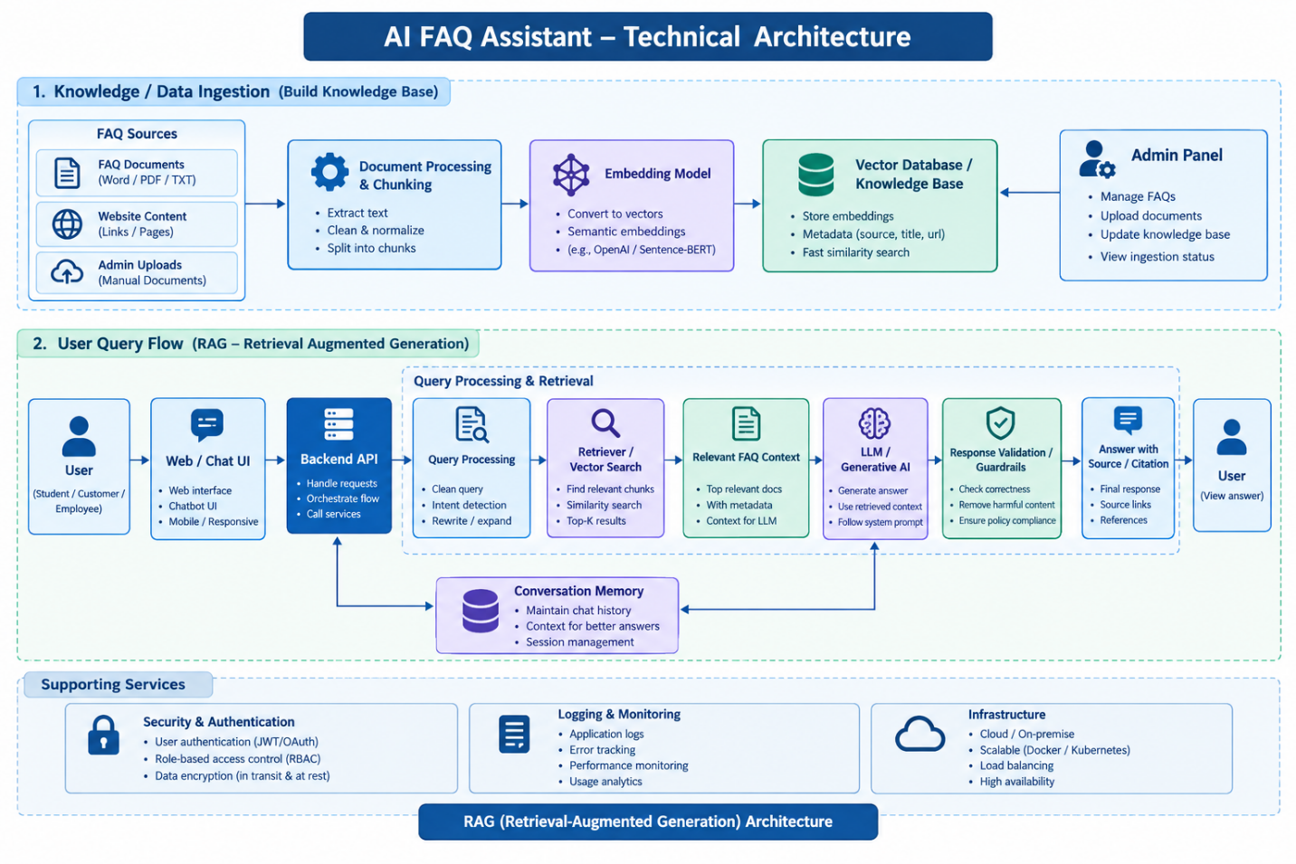

Backend Layer
- Node.js
- Express.js
- JWT Authentication
- REST APIs

Database Layer
- MongoDB
- Atlas Search
- Atlas Vector Search

AI Layer
- LLM APIs
- Embedding Models
- RAG Pipeline
- Prompt Engineering

Storage Layer
- MongoDB Collections
- File Upload Storage

Security Layer
- JWT Authentication
- Protected Routes
- Input Validation
- Role-Based Access Control

ER Diagram

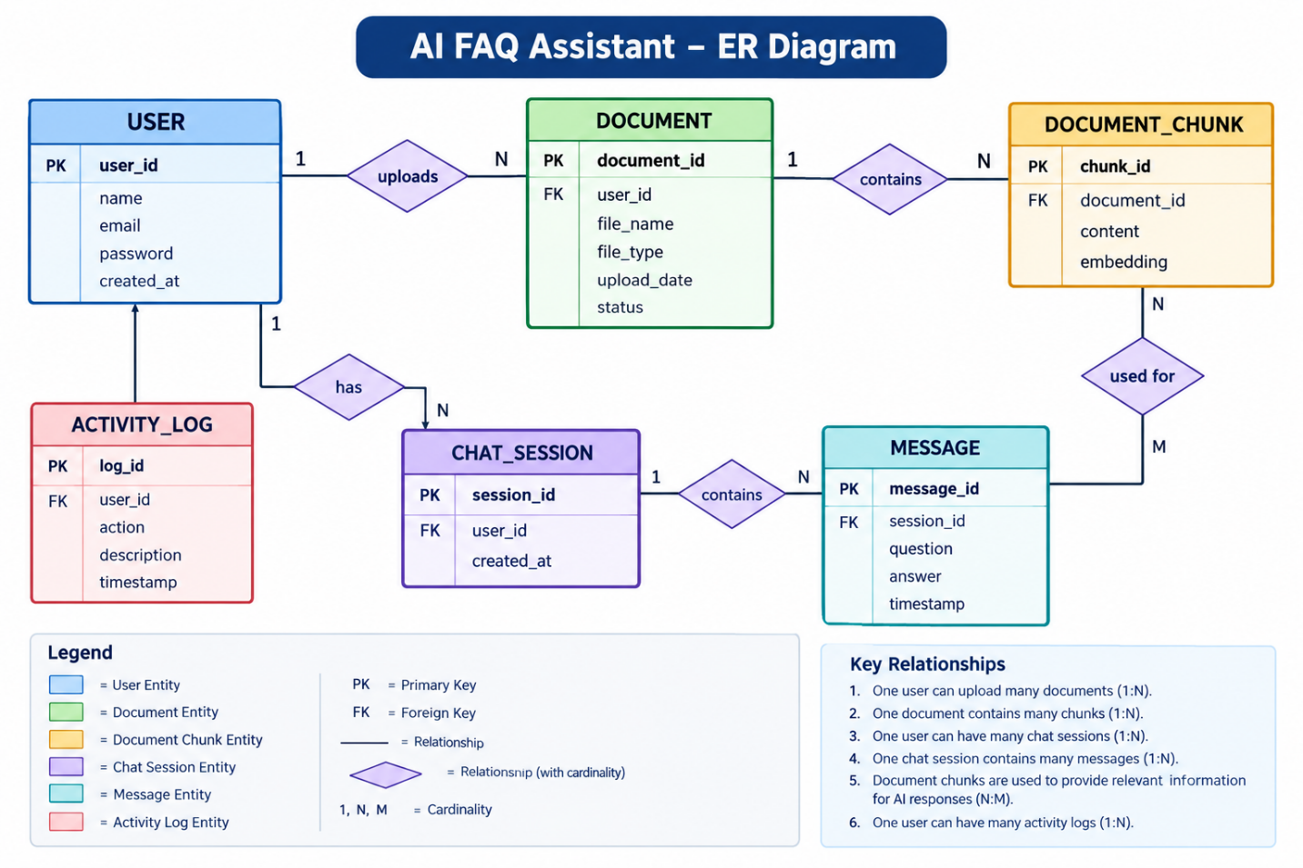Collections

Users
- _id
- name
- email
- password
- role

Documents
- _id
- title
- content
- uploadedBy
- createdAt

Embeddings
- _id
- documentId
- vectorData

Chats
- _id
- userId
- prompt
- response
- timestamp

ActivityLogs
- _id
- userId
- activity
- createdAt

ER Diagram Explanation
The ER Diagram shows how the data in the AI FAQ Assistant is connected.
- User – Stores user details.
- Document – Stores documents uploaded by users.
- Embedding – Converts document content into vectors for AI search.
- MongoDB – Stores documents and vector embeddings.
- Chat – Stores user questions and AI answers.
- Activity Log – Records user activities.

Features

Core Backend Features
- User Registration
- User Login
- JWT Authentication
- Protected Routes
- Middleware
- CRUD API
- File Upload
- Role-Based Access Control

AI Features
- AI Chat Assistant
- Semantic Search
- Vector Search
- Document Question Answering
- Text Summarization
- Content Generator
- RAG (Retrieval Augmented Generation)
- Intelligent Insights
- Natural Language Queries

Roles and Responsibilities

Admin
- Manage Users
- Manage Documents
- Monitor AI Usage
- View Analytics
- Configure System

User
- Register/Login
- Upload Documents
- Ask Questions
- Search Content
- View AI Recommendations
- Manage Personal Data

User Flow
- User Registration
- User Login
- JWT Authentication
- Dashboard Access
- Upload Documents
- Generate Embeddings
- Store Vectors in MongoDB
- User Query Submission
- Semantic Search Execution
- AI Response Generation
- Display Results
- Store Chat History

MVC Pattern
The backend follows the MVC (Model-View-Controller) architecture.

Model Layer
Responsible for:
- User Schema
- Chat Schema
- Document Schema
- Embedding Schema
- Activity Schema
Implemented using Mongoose.

Controller Layer
Responsible for:
- Authentication Logic
- AI API Integration
- Document Processing
- Embedding Generation
- Search Operations
- CRUD Operations

View Layer (Routes)
Defines REST API endpoints:

Authentication Routes
- Register
- Login
- Logout

AI Routes
- Chat
- Summarization
- Semantic Search

Document Routes
- Upload
- View
- Delete

User Routes
- Profile
- Dashboard

Advantages of MVC
- Separation of Concerns
- Better Maintainability
- Easy Scalability
- Reusable Components
- Team Collaboration
- Easier Testing

Project Setup and Configuration

Project Structure
Create Project Folder
Inside Project Folder:

Server Folder
Backend Application

Server Setup
mkdir server

cd server

npm init -y
Create:
server.js

models/
controllers/
routes/
middlewares/
config/
services/
utils/


Install Backend Packages
npm install express mongoose cors dotenv bcryptjs jsonwebtoken

npm install openai

npm install multer

npm install nodemon --save-dev


Backend Development
Include:
- Authentication APIs
- JWT Implementation
- AI Service Integration
- Vector Search APIs
- CRUD APIs
- Document Upload APIs
- Chat APIs
Note:
Proper explanation must be provided for every AI API consumed, including:

Purpose:
The AI FAQ Assistant is designed to provide quick and accurate answers to frequently asked questions using information from uploaded documents. It helps users find relevant information easily through an AI-powered chat interface and reduces the time required for manual searching.

Request Structure:
The user submits a question through the chat interface. The request contains details such as the user ID, session ID, and question. The system processes the question, searches the relevant document information using vector embeddings, and sends the retrieved information to the AI model for generating an appropriate response.

Response Structure:
The system provides a clear and relevant answer based on the user's question and the available documents. The response can include the generated answer, relevant source information, and timestamp. The conversation is stored so that users can refer to their previous questions and answers.

Cost Considerations:
The cost of the AI FAQ Assistant depends on the number of API requests, tokens processed, document embeddings, and database storage. Costs can be reduced by using suitable AI models, limiting unnecessary requests, caching frequently asked questions, and efficiently storing documents and embeddings.

Security Practices:
Security is maintained by using authentication and authorization to protect user accounts and data. Passwords are securely hashed, and user inputs and uploaded documents are validated. HTTPS is used for secure communication, while API keys are protected using environment variables. Access controls, rate limiting, and activity logs are also used to prevent unauthorized access and monitor system activities.

Database Development
Include:
- MongoDB Collections
- Relationships
- Atlas Search Index
- Vector Search Index
- Sample Documents
Provide screenshots and explanation.

Project Execution

Step 1: Backend
cd server

npm install


Step 2: Configure Environment Variables
Create .env
PORT=8000

MONGO_URI=mongodb://localhost:27017/ai_augmented_db

JWT_SECRET=your_secret_key

OPENAI_API_KEY=your_api_key


Step 3: Run Backend
nodemon server.js
Backend URL:
http://localhost:8000


Output with Explanation
API Testing:
API testing is performed to verify that the AI FAQ Assistant APIs work correctly and reliably. It checks user requests, document uploads, FAQ queries, authentication, error handling, and response accuracy to ensure proper communication between the frontend and backend.

LLM Integration:
LLM integration connects the AI FAQ Assistant with a Large Language Model to generate natural and meaningful answers. The system retrieves relevant information from uploaded documents and provides it to the LLM so that responses are based on the available knowledge.

AI Chat Interface:
The AI chat interface allows users to interact with the FAQ Assistant through a simple conversation-based interface. Users can enter questions and receive AI-generated answers in real time. Previous conversations can also be stored for future reference.

Document Upload:
The document upload feature allows users to upload files such as PDF, DOCX, or text documents. The system extracts the content, divides it into smaller sections, generates embeddings, and stores the processed information for future question answering.

Search Results:
The search feature identifies relevant information from the uploaded documents based on the user's question. The system uses vector similarity search to find matching document chunks and provides the most relevant information to the AI model for generating the final response.

Recommendation Engine:
The recommendation engine suggests relevant FAQs, documents, or related questions based on the user's current query and previous interactions. This helps users discover additional useful information and improves the overall effectiveness of the AI FAQ Assistant.

Demo Video Link
https://drive.google.com/drive/folders/1QBUnUv_en6Yrh7y7-Z1I2vn_gDwWkF7B?usp=drive_link

Source Code Drive Link
https://drive.google.com/drive/folders/1-2Tqbi4h77i2QtVftxqtvlfrHz4EfElj?usp=drive_link

Mandatory Functionalities
- MVC Architecture
- JWT Authentication
- Semantic Search
- MongoDB Atlas Search
- MongoDB Atlas Vector Search
- Prompt Engineering
- AI API Integration
- Role-Based Access Control

